Opencast-KLIPS (OCLIS) Semester Scheduler

The objective of this guide is to show the steps and requirements to use the web application for scheduling all the lectures through it.

# Introduction

The Opencast-Klips Semester Scheduler (Called onwards OClis), is a web application that allows you to schedule an entire course without manually re-enter the information in the Opencast System, this allows to avoid transcript errors and saves time with lectures that have complex schedules and in different rooms.

## Requirements:

To use the Oclis web application is needed to have before:

* A series created in opencast with the respective access lists.
* Access to the Klips system, especially the Courses calendar.

# How to Schedule a complete course

## Step 1: Gathering the requested data

The first thing is to get from the series the ID (UUID), this is an alphanumeric code located in the details of the series. It can be found in the Opencast admin UI.

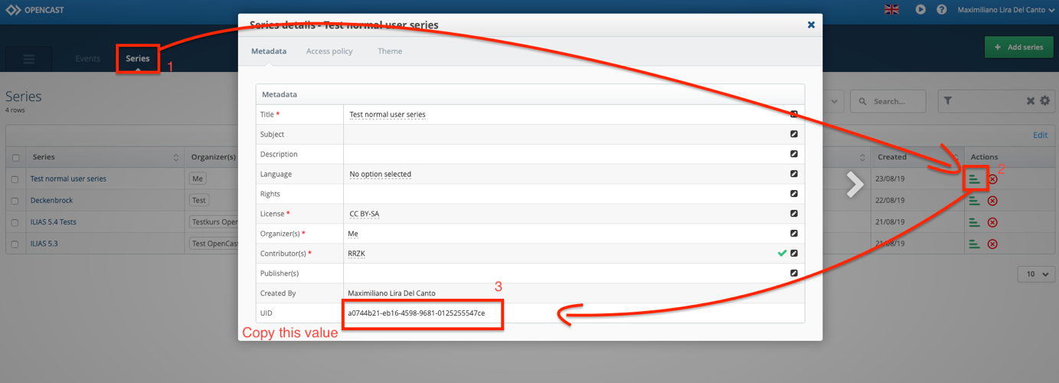

Figure 1: Click Series, then go to series detail and finally copy the UID from the series

To do this, inside the Opencast admin UI, go to the tab “Series”, open the series detail from the series who will hold the scheduled events, later, copy the “unique identifier” (UID).

## Step 2: Get the XML file from the Klips system.

1. Enter the Klips system and go to the details of the lecture to schedule.
2. On “Abhaltungstermine”, click details.

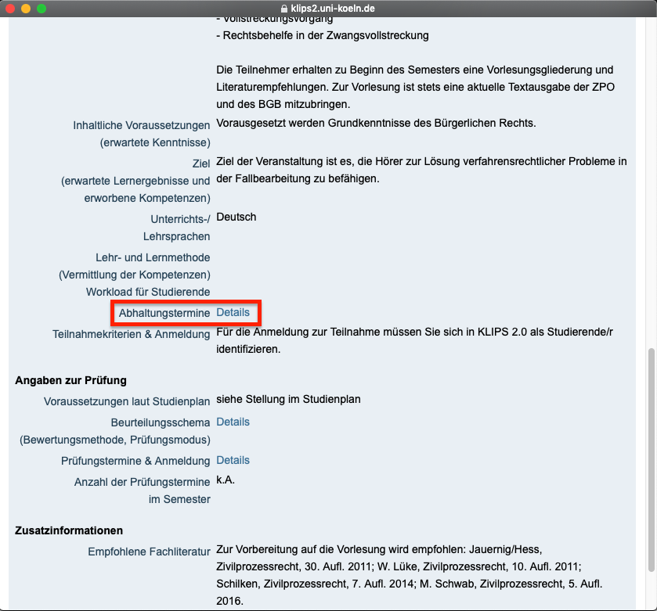

Figure 2: Enter to the termine details from the course

1. In the top right corner click “Export”

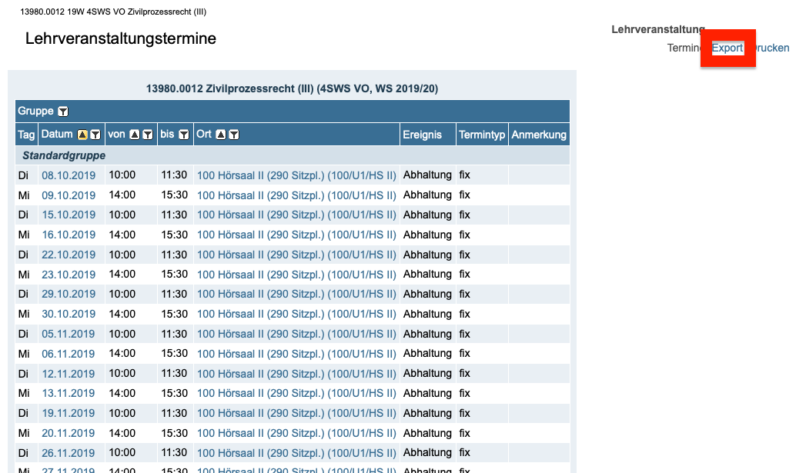

Figure 3: Click "Export"

1. Export the file and download it to your machine with these settings:
   1. Download as XML
   2. Zeichensatz: UTF-8
   3. Exportoptionen LV-Termine
      1. LV-Vortragende exportieren, wenn kein Terminvortragender zugeordnet

Figure 4: Download the XML file with the options as Shown

## Step 3: Schedule on Opencast:

Enter to OCLIPS:

<http://oc-aurora.uni-koeln.de/oc/scheduler>

As the time of writing, this is only scheduled in the Opencast test cluster.

On Inputs:

* Submit the recently downloaded XML file
* Paste the Series ID that was copied from Opencast
* For being a Test environment, force a capture agent. The capture agents from the real classrooms are not registered in the test system.

Select the workflow options that are suitable for this course.

Finally, push the button "Schedule series". The site will start to work, but you will not see (For the moment) a loading bar. When finished it will show a message that the scheduling is completed.

# Known issues:

* **If there is no capture agent for the classrooms** where the lectures will be, the schedule will fail.
* **Trying to schedule over the already scheduled course** will lead to an error.
* **If the series ID is incorrect** it will fail the schedule.